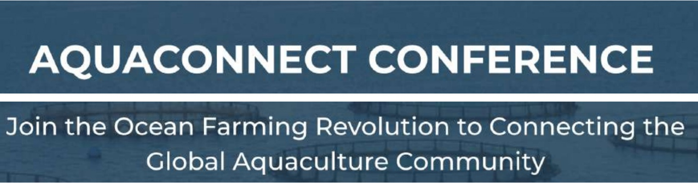
SEPTEMBER 8TH - 9TH, 2023
Day 1 - Friday, September 8th, 2023
Speaker Lineup
Oren Klaff | Keynote Speech
Claire Pribula | "From Seed to Success: How Transformational Relationships Drive Venture Capital Investment Growth"
Tony Chen | "Artificial Intelligence in Sustainable Aquaculture"
Matt Craze | "Data in Sustainable Aquaculture"
Lee Brower | "Stewardship"
Day 2 - Friday, September 9th, 2023
Speaker Lineup
Philippe Delespesse | "How to generate innovative solutions to your challenges"
Miguel Knudsen | "The Future of Investing in Aquaculture is Sustainable"
Dolian Barkallah | "Web3 in Aquaculture: Ecology, Blockchain, and Gaming"
Lourdes Gant | "Trends in Sustainability"

